الجمهورية اللبنانية
الاسم والشهرة:--------------------
رقم المرشح :----------------------
وزارة التربية والتعليم العالي الامتحانات الرسمية لشهادة الامتياز الفني
المديرية العامة للتعليم المهني والتقني لدورة عام 2021 الثانية
=================
الإختصاص والرمز : المعلوماتية الادارية (23104)
المادة : برمجة ويب Web المعدل : (10 )
المستندات المسموح بها: لا شيء المدة : ساعتان
الإجابات على "كراس الإجابة"

Treat the following questions

- Choose the correct answer: (1 pt / correct answer)

- Which of the following input control is used for input fields that should contain an URL address in Web Form 2.0?
- email
- url
- web
- Which of the following is not a HTML5 tag?
- <source>
- <video>
- <slider>
- An Article element contains :
- Text or embedded content
- Image
- Audio
- What will happen if height and width of video are not set while video loads?
- The page flickers
- The page does not load
- The page crash
- What is the correct HTML tag for adding a background color?
- <body background=”yellow”>
- <background>yellow<background>
- <bold style=”background-color:white”>
- Which attribute will play the audio embed in the audio element continuously?
- preload
- control
- loop
- Which among the following is correct HTML code for making a checkbox?
- <checkbox>
- <input type=”checkbox”>
- <input type=”check”>
- What are the types of unordered or bulleted list in HTML?
- disc, square, triangle
- polygon, triangle, circle
- disc, circle, square

- How can you created rounded corners using CSS?
- Corner-effect: round;
- Border[round]:30px;
- Border-radius:30px;
- How do you make a list that displays its items with squares?
- list-style-type: square;
- list: square;
- list-type: square;

- Show the purpose of each of the following Web form controls : (2 pts)
- date input control
- month input control
- range input control
- month input control

- Write the corresponding HTML5 tags and the appropriate CSS properties to obtain as
result the following page: (3 pts)

Player # | Country | Rank | Team | Golden ball | Adv. Cost
1 | Europe | A | Real madrid | 4 | 450,000
2 |  | A | AC Millan | 1 | 258,000
Total |  |  |  | 5 | 708,000
الإختصاص والرمز : المعلوماتية الادارية (23104)
المادة : برمجة ويب Web

- The table has the following characteristics:
    - Width: 500 pixels • Height: 50 pixels • Space between borders: 2 pixels.
- The table border thickness is 5 pixels and the cells border thickness is 2 pixels.
- The background color of the first row is blue and for the last row is green.

- Write the appropriate HTML5 tags to obtain the following form : (5 pts)
This form has the following properties:
  - Background color is green. (Use rgb, rgba or hexadecimal code)
  - Position: absolute, 100 pixels from the top of the page and 20 pixels from the left of the page.
  - Font color: White. .(Use rgb, rgba or hexadecimal code)
  - Text alignment: left, 16 pixels.

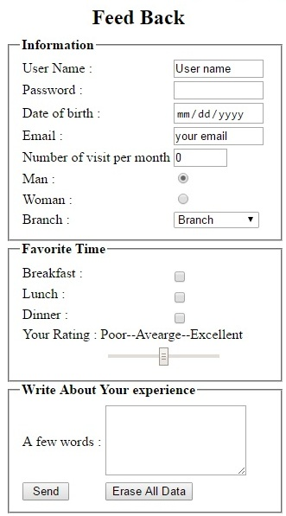 | - User name: Input field, 40 visible characters, and maximum 25 characters.  - Password: Input field, 40 visible characters, and maximum 16 characters, a hidden character "●" must be displayed instead of the characters.  - Indicate the appropriate type for the following fields: Date of birth, Email.  - Number of visit per month: Input field of type number, maximum value: 31, minimum value:0, default value:0.  - Man / Woman: Radio button, only one choice is acceptable.  - Branch: Combo box that contains the following values :  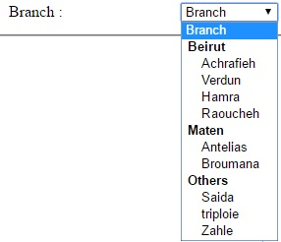  - Breakfast / Lunch / Dinner: Checkbox, many choices are acceptable.  - Your Rating: a scale from 1 to 17, the default value is 9.  - A few words: input fields 5 lines; 20 characters per line.  - A button Send that send all data to the email: info@restaurant.com.  - A button Erase All Data to return the document to the initial state.

